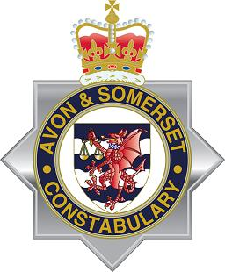

CHIEF CONSTABLE FOR AVON & SOMERSET
AUDIT OF ACCOUNTS YEAR ENDED 31 MARCH 2024
NOTICE OF PUBLIC RIGHTS

Local Audit and Accountability Act 2014
The Accounts and Audit Regulations 2015

Notice is hereby given under Regulations 15(2)(b) of the Accounts and Audit Regulations 2015 that from 10th June 2024 to 22nd July 2024 between 9.30am and 4.30pm on weekdays any person may inspect, and make copies of the accounts and all books, deeds, contracts, bills, vouchers, receipts and other related documents of the Police & Crime Commissioner (PCC) and Chief Constable (CC) for the year ended 31 March 2024, as stipulated in Section 25 of the Local Audit and Accountability Act 2014. The accounts and other documents will be available for inspection at Police Headquarters, Valley Road, Portishead, Bristol. BS20 8JJ by prior appointment. Please telephone 01278 646188 to make an appointment. The accounts will also be available on the Police and Crime Commissioner’s website.

During this period, a local government elector for any area to which the accounts relate, or their representative, may question the auditor about the accounts, or make an objection to the accounts as set out in Sections 26 and 27 of the Local Audit and Accountability Act 2014. Any objection, and the grounds on which it is made, must be sent to the auditor in writing, with a copy to the Chief Constables Chief Finance Officer, at the address below. Any objection must state the grounds on which the objection is being made and particulars of:

- Any item of account which is alleged to be contrary to law; and
- Any matter in respect of which it is proposed that the auditor could make a public interest report under Section 24 of, and paragraph 1 of Schedule 7 to, the Local Audit and Accountability Act 2014.

Objections should be addressed to the auditor, Julie Masci, Grant Thornton UK LLP at Grant Thornton House, 110 Bishopsgate, London. EC2N 4AY.

A guide to your rights can be found at https://www.nao.org.uk/code-audit-practice/wp-content/uploads/sites/29/2015/03/Council-accounts-a-guide-to-your-rights.pdf

10th June 2024

Nick Adams,
Chief Officer – Finance, Resources and Innovation
Avon & Somerset Constabulary
Valley Road, Portishead, Bristol. BS20 8JJ

