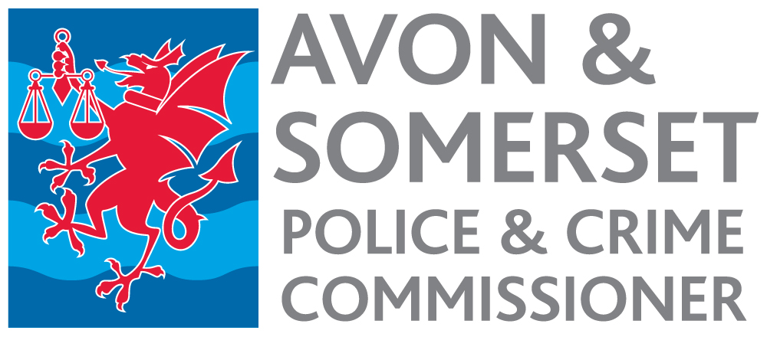

Senior Communications Manager
Appointment process 2023

Timetable

Date | Activity
w/c 31 July 2023 | Advertisement published.
12 noon 18 August | Closing date for receipt of applications.
w/c 21 August | Short listing.
w/c 28 August and 4 September | Selection Day.
October- December | Start date, depending on notice period.

