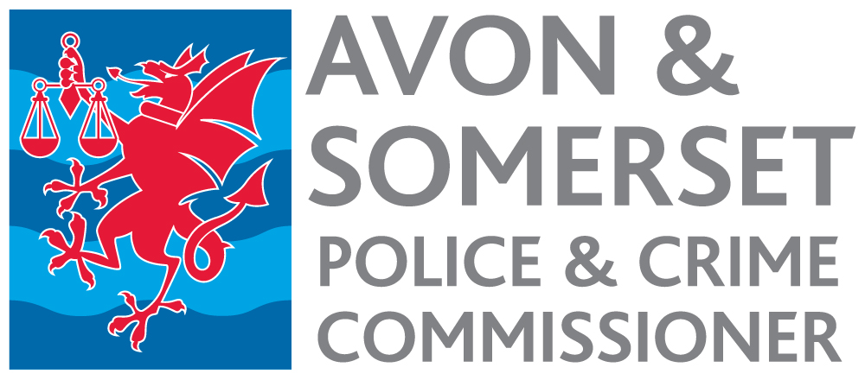

Policy and Commissioning Support Officer
Appointment process 2023

Timetable

Date | Activity
18 May 2023 | Advertisement published.
12 noon 8 June | Closing date for receipt of applications.
w/c 12 June | Short listing.
15 June | Notification to short-listed candidates.
28 June | Selection Day.
4 July | Notification to successful candidate.
September 2023 | Start date, depending on notice period.

