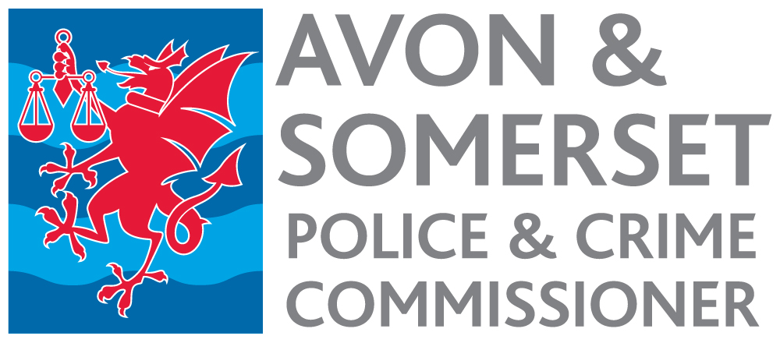

Engagement and Events Manager
Appointment process 2022

Timetable

Date | Activity
Week commencing  19 September | Advertisement published.
12 noon 31 October | Closing date for receipt of applications.
3 November | Short listing.
4 November | Notification to short-listed candidates.
w/c 7 November | Selection Day.
11 November | Notification to successful candidate.
January/February | Start date

