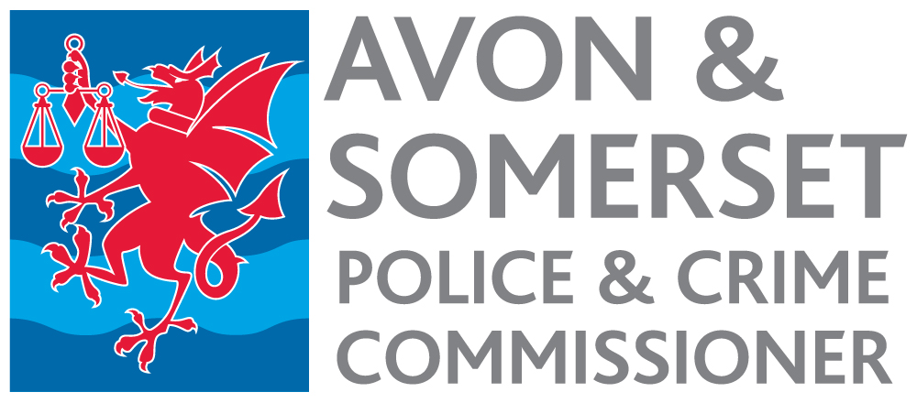

HR Support Officer
Appointment process 2022

Timetable

Date | Activity
29 June 2022 | Advertisement published.
12 noon 3 August | Closing date for receipt of applications.
9 August | Short listing.
10 August | Notification to short-listed candidates.
w/c 15 August | Selection Day.
19 August | Notification to successful candidate.
Early October | Start date.

